Amazon Music Clustering

Interpretation: Clustering Techniques
Option: A - K-Means Clustering:
Goal: Apply one or more clustering algorithms to group the songs.
Step1:
- Find the best optimal K using Elbow Method
- By assigning the K = range(2,11)
- Looping those K values and by inertia
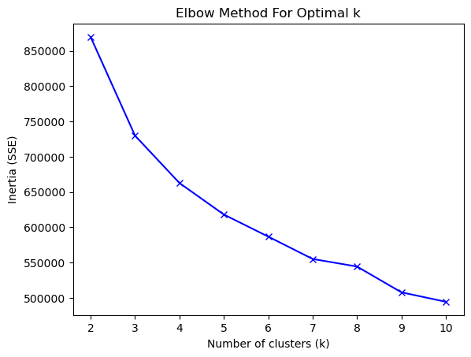
- From the above Trend can able to find the optimal K = 3 but we had another step weather these K values perform well in silhouette_score evaluation.
- So in Evaluate process we are the same K = range(2,11)
- By this can able to find which K value perform well

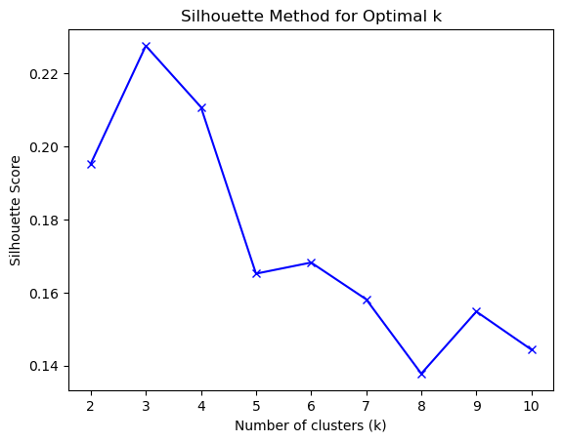

- By the above trend can able to derive that best silhouette_score for K value 3 provides us a good score compare to others.
- So we are approaching the clustering problem with K = 3.
- After proceeding with K = 3 value we are assigning df[‘cluster’] = kmeans.labels_
- Then summarizing and groupby cluster with their mean().

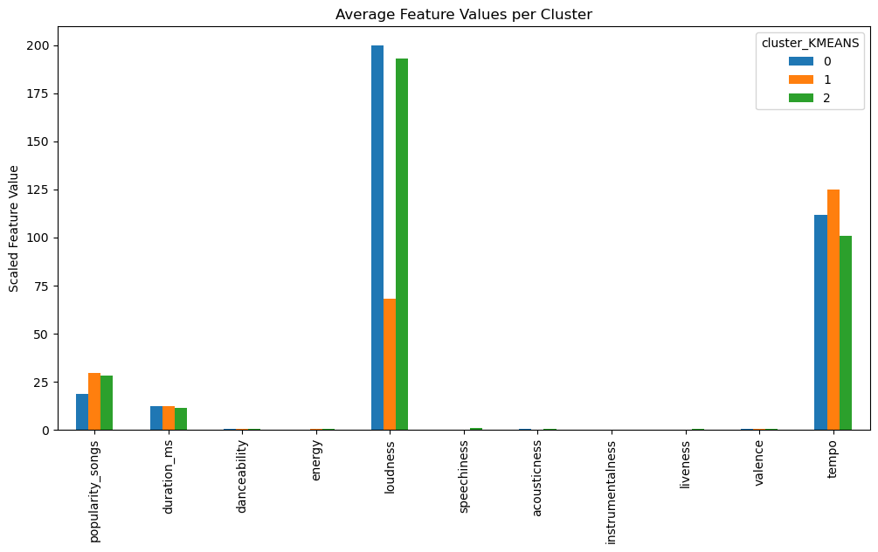

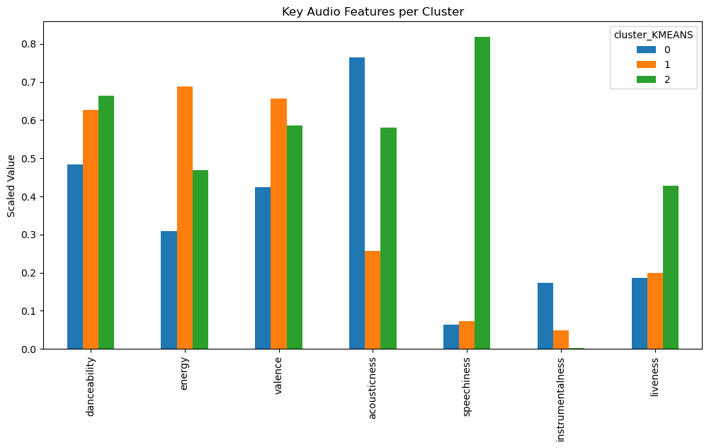
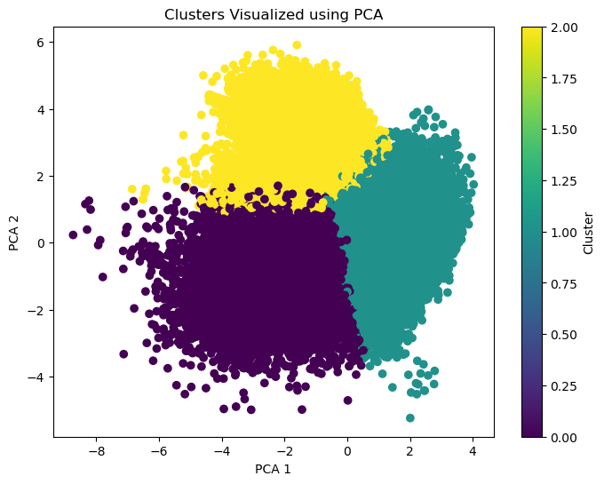

Interpretation of Average Feature Values per Cluster:

The two charts together illustrate how the three clusters differ across both overall and key audio features.

Cluster 0 (Blue)

shows high loudness and acousticness but lower energy, danceability, and valence, indicating songs

that are calm, acoustic, and less upbeat. These tracks are likely to be soft, relaxing, or unplugged

versions with lower tempo and energy.

Cluster 1 (Orange)

stands out with high energy, danceability, and valence, along with high tempo and

moderate loudness.

This suggests that songs in this cluster are lively, energetic, and positive, representing

party or feel-good tracks with

strong beats and higher rhythm intensity.

Cluster 2 (Green)

Has balanced danceability and energy, higher speechiness and liveness, and slightly

lower loudness and tempo than the other two.

This profile indicates live performances, vocal-heavy, or spoken-word style songs, which

are more expressive and interactive.

Overall Summary
- Cluster 0: Calm/Acoustic Tracks
- Cluster 1: Upbeat/Party Songs
- Cluster 2: Live/Vocal Tracks

